**GIT Department of Computer Engineering**

**CSE 222/505 - Spring 2022**

**Homework # Report**

**Student Name: Muhammed Alperen Karaçete**

**Student Number: 171044052**

1. **SYSTEM REQUIREMENTS**

User:

Must set street length.

Must add buildings on street.

Must set features of buildings.

Must delete buildings from street.

Must see remaining lands on street.

Must see list of buildings on street.

Must get information about total length occupied by markets,houses and offices.

Must display skyline silhoutte.

1. **USE CASE AND CLASS DIAGRAMS**

USE CASE DİAGRAM: CLASS DİAGRAM

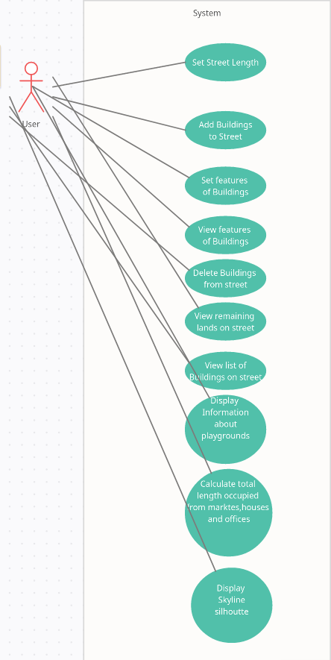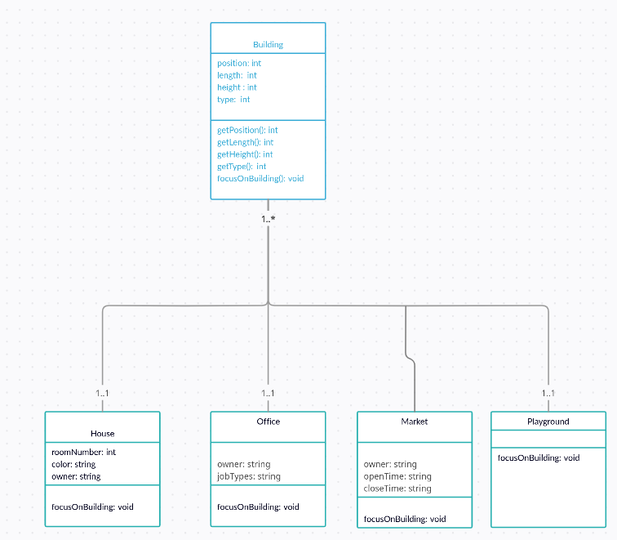

1. **PROBLEM SOLUTION APPROACH**

Taking buildings from user and place them into to the two sided street.Buildings can not be overlap.User can not enter not valid entries.I used make street function to control if user entries valid to place that building to street.If it is not I take entries again.Then with Draw street function draw that building to array.

1. **TEST CASES**



1. **RUNNING AND RESULTS**

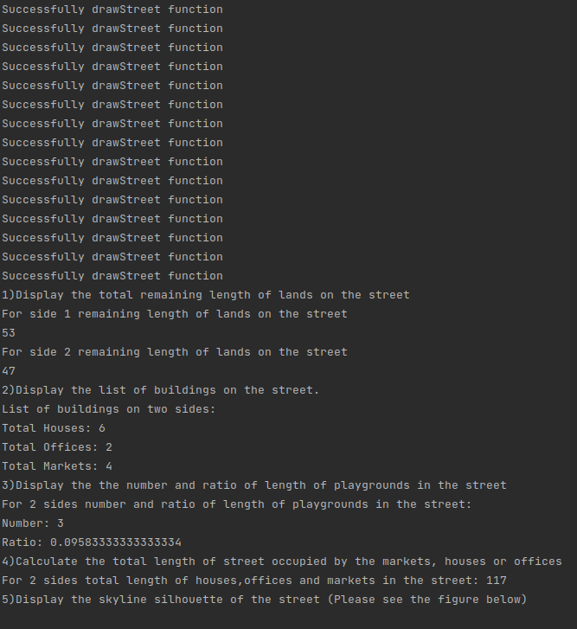

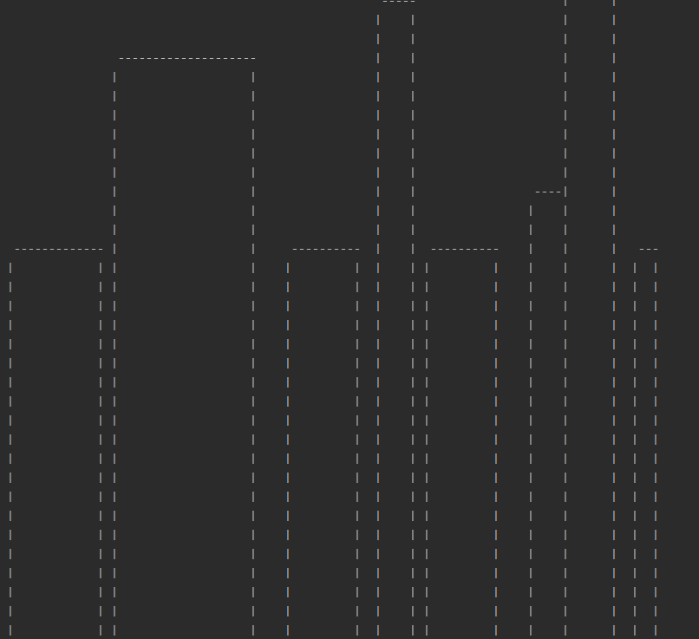

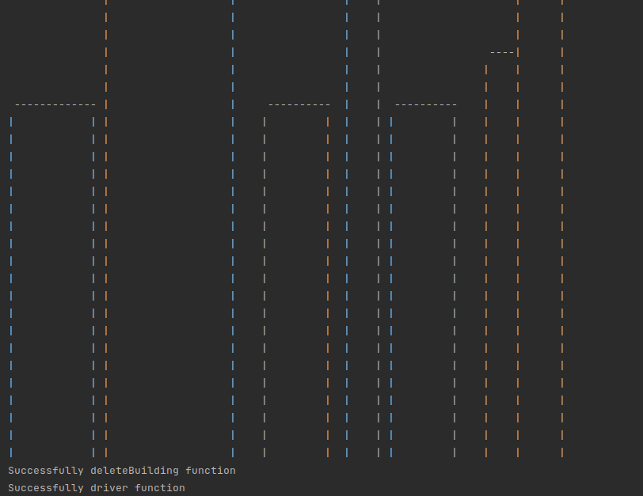

Time complexity:

My code complexity is :Two while loop in one for loop.So it’s O(n^3)

In Program:

Adding 9999 house to street takes 7.31 seconds,

Adding 5000 house takes 3.85 seconds,

Adding 1000 house takes 0.91 seconds,

Deleting 9999 house takes 1 seconds,

Deleting 9999 house takes 1 seconds,

Deleting 9999 house takes 1 seconds,